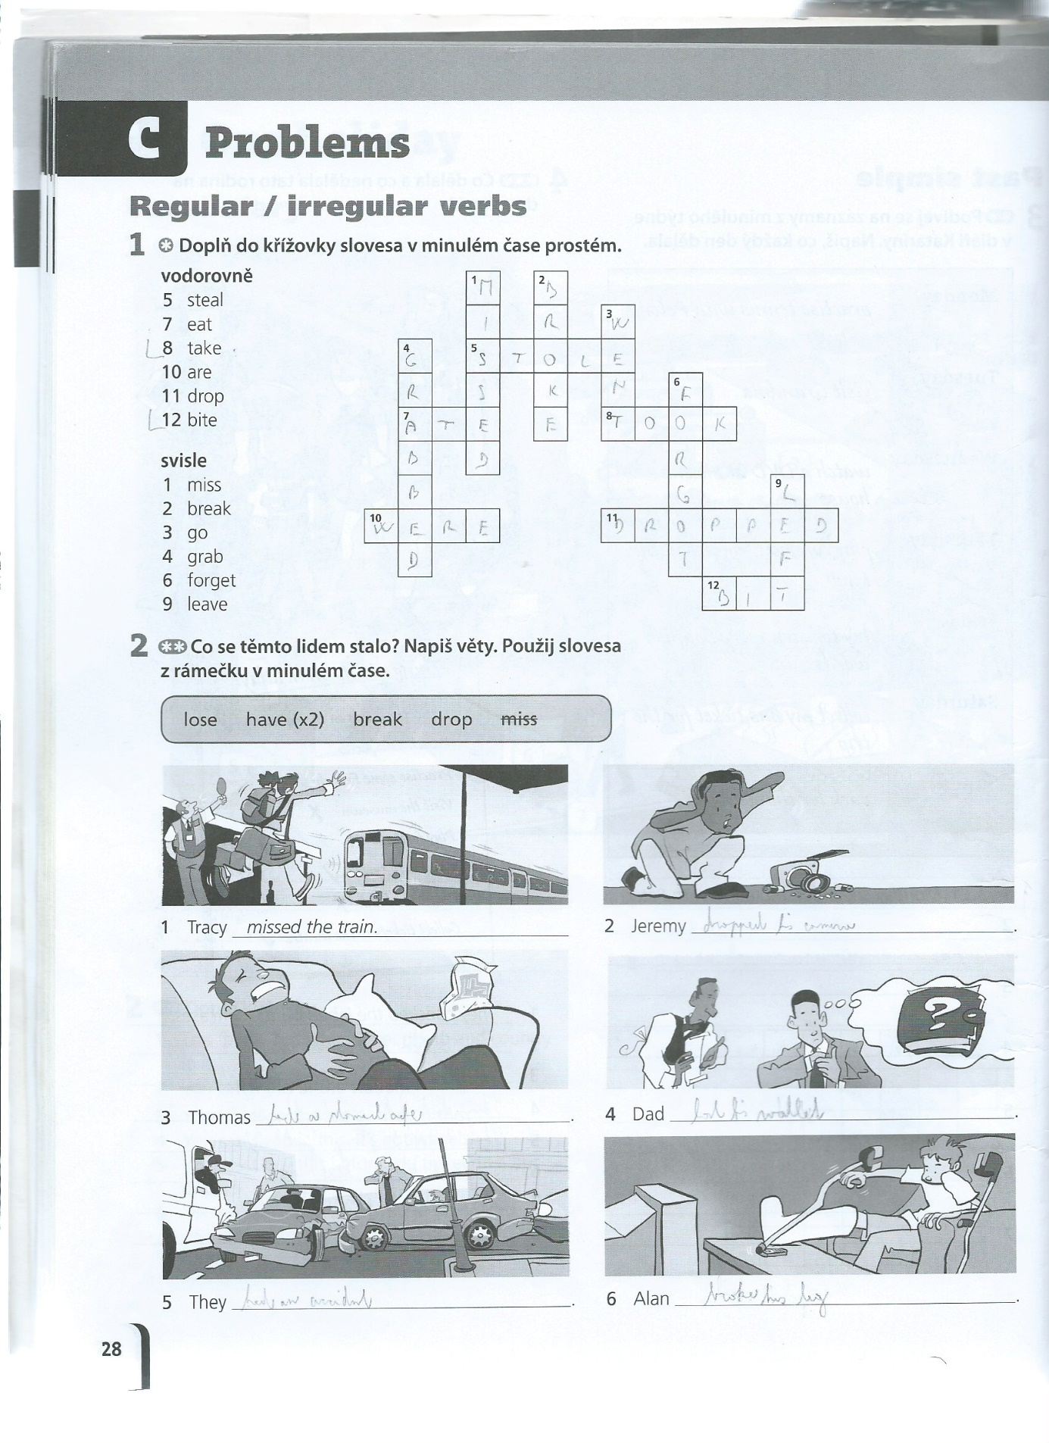

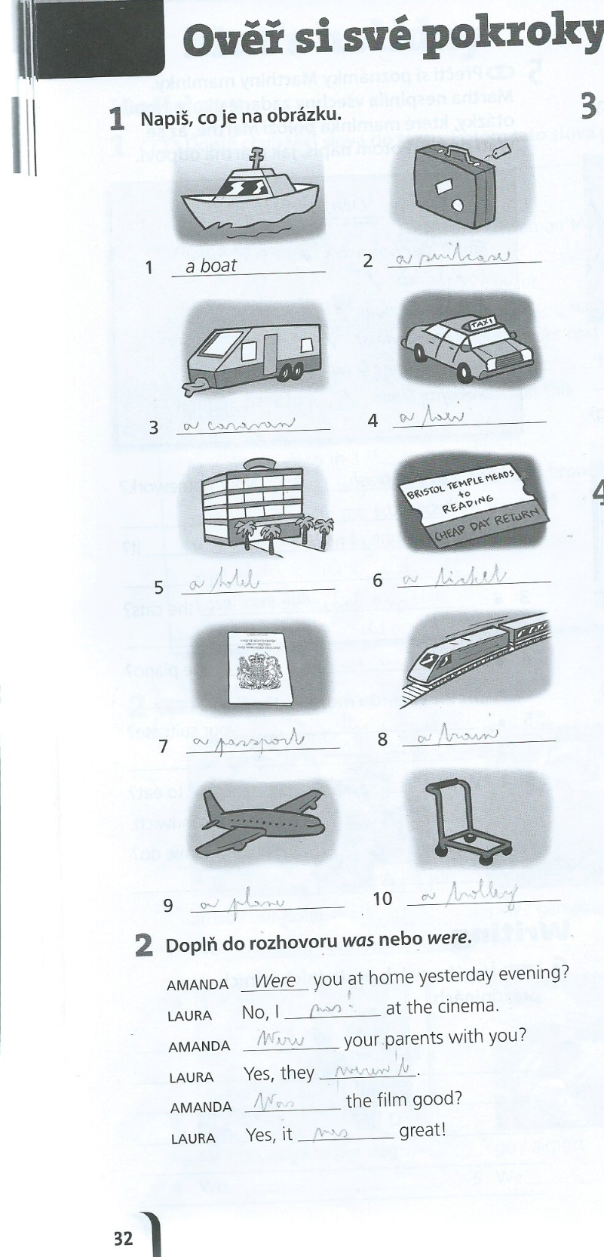
uč. str. 36/2
lost
went
had
dropped
missed
broke
rained
closed

